Core|HR: Organisational structure

Contents
Document Version Control 1
Approved process for raising 2
Consultation & Approval 2
Change Management 2
How to 2
Testing 4
Communications 4
Downstream Systems & Processes 4
Affected Reports 5
Additional Background Information 5

Document Version Control
Change History/Review Details
Date | Version | Review by | Summary of Change
6/04/2017 | V0.1 | HC | Created draft
15/05/2017 | V0.1 | AJA | Reviewed and added comments
6Feb18 | 1.0 | HC | Finalised
14 Jun 18 | 1.1 | HC | Updated following discussion with the HR Information team about timescales and data quality. Also added information about workgroups and continuous service.
Aug 21 | 1.2 | HC | Portal updates
Feb 22 | 1.3 | HC | Updated to add further information regarding Continuous service and user access since the implementation of Coretime. Also added details of the UDF 'Roles in Department'
Feb 23 | 2.0 | HC | Updated to include details about temporary reinstatement of org hierarchy in order to assign or disable user access.

Approved process for raising
Does the change need to be raised through a particular route or by a particular person/team? Are there any actions which need to be taken or considered prior to processing in the HRIS Support Centre?
Changes should be requested by the Functional Analysts and authorised via a change request in OSM following the approved change request process. The details to enter in the Change request are included in the ‘How To’ guide. However, the simplest option is to clone a previous change and update the relevant details.

Consultation & Approval
Who is the owner of this information? Who needs to be consulted about this change before you begin work on it? Does anyone need to approve this change before it is implemented?
Requests to change this data will generally be received from PRAS, either as an ad hoc request or when the annual organisation chart is produced in July/August each year. An interim file is normally produced in February.

If the changes will result in employee records being transferred, timescales should be discussed and agreed with the Data Service Team and the HR Analytics Team. The Data Service Team will be transferring the employee records from the old to new hierarchy, using the Restructure Tool, and the HR Analytics Team will want to ensure that all data quality errors are cleared under the old appointment before the employees are transferred.

Change Management
What type of change is this? When should approval be sought and from whom (internal to team or change manager)? Who would normally be responsible for implementing?
The change(s) must be requested or approved by PRAS before implementation.

Permanent system changes must be approved by the System Owner (the Head of HR Systems) or their nominated deputy, via the change request in OSM, ideally before implementation.

Temporary system changes to enable user access to be updated can be made under a standard change – see Additional Background Section for more details.

How to
Technically how to process the change in the system

Full details can be found in the guide - HOW TO Manage the org hierarchy

Adding a new department, unit, etc.
Navigate to: Core Personnel > Maintenance > Post Management > Organisational Hierarchy

- Create the new department, unit, etc. as required, then open the Hierarchy and expand the structure to get to the level where you want to add the new item. Ensure the correct level is highlighted and click the button to add the new item.

- Multiple items can be added at the same time provided they are all being added at the same level e.g. multiple departments being added to a new management unit.

- Ideally historical codes should not be re-used. However, it may be possible to re-use a department code if the following are true:

There have never been employees appointed to the original department (That are visible in CoreHR)

OR

Previous employees exist but the new department is in the same Division and Mgmt Unit and the same departmental users will have access. This must be approved by the HRIS Guardian or equivalent for the original department and the Head of HRIS Support.

- Changes are saved straight away.

Changing a name
Navigate to: People Management > Data Centre > Reference Data

To process a name change, you just need to update the description in the reference data.

Depending upon the level being changed, you may also need to change other data items to correspond; e.g. a department name change is likely to require a change to the ‘pay admin by department’ description and possibly the location code.

Refer to the HOW TO guide for full details: HOW TO Manage the org hierarchy

Moving a department
Navigate to: Core Personnel > Maintenance > Post Management > Organisational Hierarchy
- The department should be added to the new position in the hierarchy and any current employees should be moved to the department’s new position by Data Services.

- Multiple items can be selected to be moved at the same time.

- Once the employees have been moved, the department can be deleted from its old position in the hierarchy.

Removing a department, unit, etc. completely
Navigate to: Core Personnel > Maintenance > Post Management > Organisational Hierarchy

- Run Discoverer report PERDEP01 to check if there are any active employees.

- Once the employee records have been moved and/or no current employee records are appointed to this department:

- Add the department to the old department codes section of the hierarchy under the relevant division and delete it from the existing position in the hierarchy.

Standard Icons & Terminology
Standard Button Names  Enter Query button:  Previous Record button:   Previous Section button:   Save button:   Insert Record button:  | Execute Query button:  Next Record button:   Next Section button:  LOV button:   Delete Record button:  | Cancel Query button: 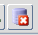  Red Door button:   Duplicate Record button:
Navigation Paths

Core Personnel > Maintenance > Post Management > Organisational Hierarchy
Other Standard Terminology

Post Restructuring Tool
The Post Restructuring functionality allows you to change the Organisation Structure. The Restructuring option can be accessed within the Personnel Module.

Navigate to: Maintenance> Post Management> Post Restructuring

Testing
Who would normally be responsible for testing? Are there standard items to test?
If necessary the HRIS Analysis team will test the changes in a suitable test environment. Full testing is only required if a change is being made that has not be carried out in the past. Creating new or renaming existing departments/units does not need to be fully tested as significant testing has already been completed on these. However for audit purposes you should test at least one of each change type being made.

Once you have made the changes you should complete the following for all Name Changes and New Departments/Units/etc. to ensure that the new hierarchy can be selected:

Create a new post (without saving if in PRD)
Create a vacancy (without saving if in PRD)
Create a staff request (without saving if in PRD)
Create a casual worker appointment (not in PRD)

Communications
Who needs to be informed (but not consulted) about this change? Detail when they should be informed (before or after the change).
After the changes have been made the following teams should be informed:

Payroll – (The Data Service Team will usually do this)
Reward team?
HR Information team
HRIS Systems Analyst

Downstream Systems & Processes
Details of any processes which are affected or need to be carried out following, or as part of, the change. Please detail any triggers, actions required and when the actions should be carried out.
Security
Notify the System Administrator of any changes to Departments as this can affect a user's access to CoreTime (WFM) due to the way user access is assigned for this module.

Employee records
Where applicable, employee records will need to be moved from the old structure to the new structure. Where new departments are created employees may also need to be moved from an existing department to the new department. This is done via the restructuring tool, details of which can be found later in this document.

Workgroups
New workgroups may be required, existing workgroups may need to be amended and/or renamed or removed from use. New workgroups should be requested by the department via a service request(s).

Depts. database
This database is updated by the HRIS Data Service team. Any changes to locations including new codes created and deleted codes should be referred to the Data Service team.

Continuous Service rules
Continuous service rules are primarily set at sub division level and based on employee status. However, in some circumstances new departments may need to be individually added to or removed from the continuous service rules. You should check that any new entity (Division through to Department) is covered by the existing Continuous Service eligiblity rules. If it isn’t, the Policy team will need to advise on whether a new Continuous Service rule should be created.
NB: If applicable Continuous Service rules should be updated to coincide with the other changes being made.
Entities under Colleges, Companies and Subsidiaries generally do not qualify for continuous service but those under Societies do.

UDF 'Roles in Department'
This UDF contains a list of all departments under each division. Any changes made to departments needs to be manually updated here.

X5
Notify the X5 administrator?

Affected Reports
Are there any standard reports which may need to be updated following this change?
None. All affected reports should show the updated hierarchy automatically.

Additional Background Information
Any other relevant information, links to supporting documentation etc.
It may be useful to view the current published version of the University org chart.

For temporary changes to the org hierarchy refer to this additional documentation.

Hierarchy explained
Multiple hierarchies can be created but it is not advisable to use more than one within the same organisation.
Although the individual components can be created in the Portal the full hierarchy can only be viewed in the Back Office.

Core Personnel > Maintenance > Post Management > Organisational Hierarchy

- Viewing the structure

  - To view the hierarchy setup within CoreHR, select ‘Data’ next to the hierarchy name.

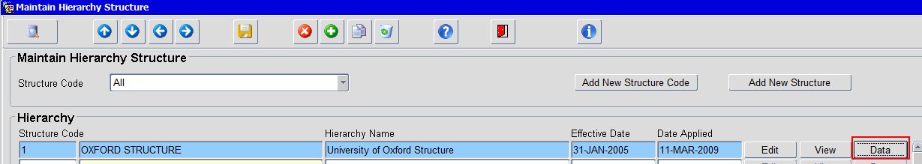

The following screen is displayed with the structure collapsed:

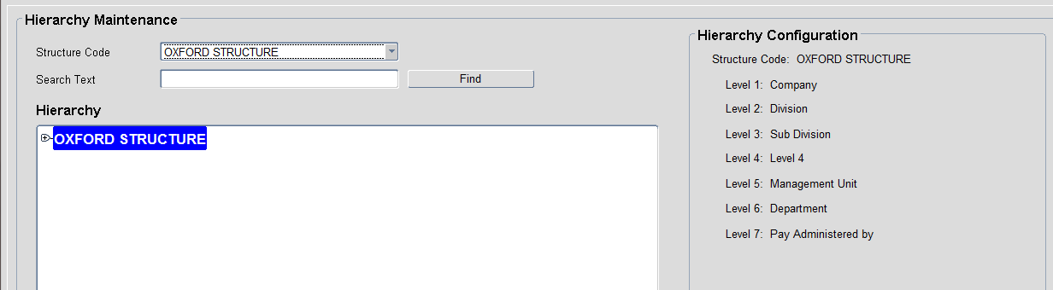

  - To expand the structure click on the small + signs. (You can display all levels from Company through to Pay admin by).

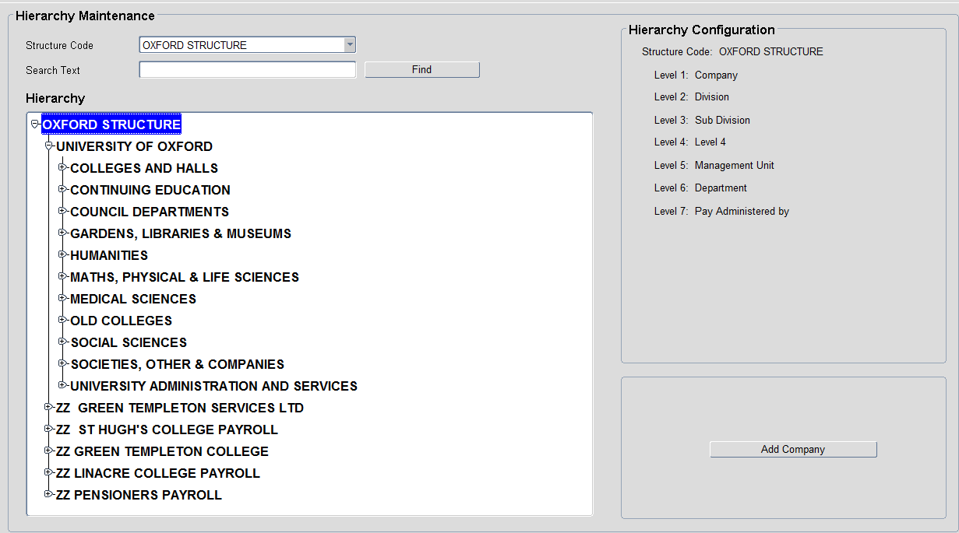

As you select an item in the hierarchy, options appear in the bottom right of the screen to add or delete items from the hierarchy. The options change depending on which level of the hierarchy you have selected.

 NB: You can’t see any codes in this view and lots of levels have the same description so it is important to know where you are before you take any action.
Full details are explained in the ‘HOW TO’ guide.

- Viewing the structure

To view the individual reference data items, select ‘View’ next to the hierarchy name.

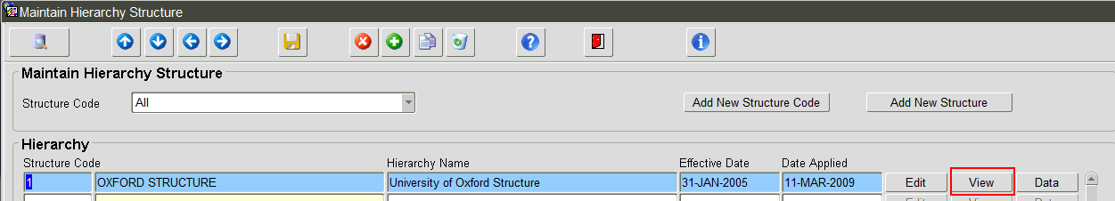

The following screen is displayed:

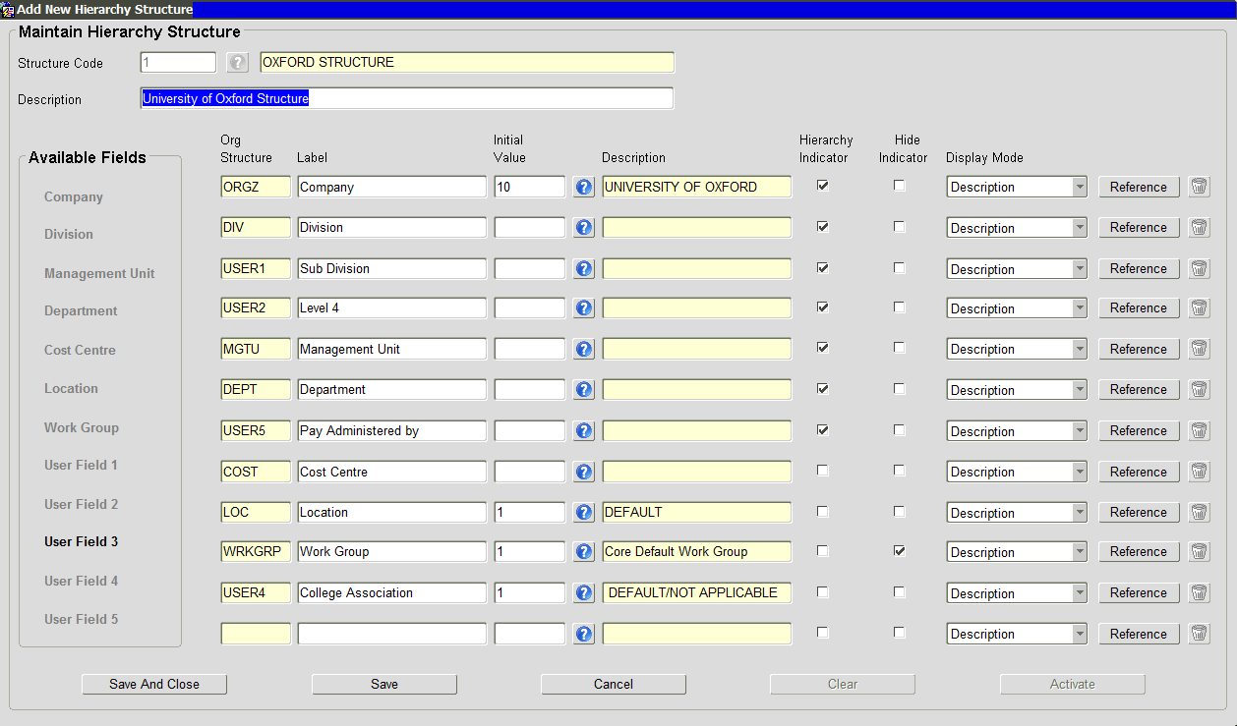

Available Fields
Fields that can be used to build a hierarchy. The order they appear in never changes and is a system default. You do not need to use all of the available fields.

NB: USER1 – USER5 are reusable fields designed to be configured for use anywhere in the org structure hierarchy.

The main body of the screen shows the details of the Oxford Structure, which fields we have used and if they are linked into the hierarchy, see the ‘Hierarchy Indicator’. Reading from the top down, we have chosen to build our structure as follows:

Label | Field Name | Description
Company | ORGZ (numeric) | Default value of 10.
Division | DIV (numeric) | Details of mapping of this numeric field to the alpha numeric division code can be found in the CDD.
Sub-Division | USER1 | Matches Level 1 entities in the PRAS structure.
Level 4 | USER2 | A grouping of management units. Only used in a few places e.g. Bodleian Libraries.
Management Unit | MGTU | Matches Level 2 entities in the PRAS structure.
Department | DEPT | Generally matches Level 3 entities in the PRAS structure.
Pay Administered By | USER5 | Used to control access to salary approvals. It allows appointments in the department to be ‘administered by’ the divisional office.
Cost Centre  (User field 1) | COST | Default value of 0000000000000.
Location  (User field 2) | LOC | Default value of 1.
Work Group  (User field 3) | WRKGRP | Default value of 1.
College Association | USER4 | Used for joint appointments.

The Company to Pay Administered By fields are linked in the hierarchy; therefore when selecting values for a field in the hierarchy, the available choices will be dependent upon your selection higher up the list – e.g. if you select Division 2 (Medical Sciences Division) you will only see Sub-Divisions that have been linked to Division 2 and so on.

The remaining fields are not linked in the hierarchy; therefore when selecting values for these fields, you are able to select from the full list of reference data.

Wherever possible the formatting below should be applied to the Codes in the system:

Name | Description | Code format
Division | Details of mapping of this numeric field to the alpha numeric division code can be found in the CDD. | Numeric  1,2,3,4,5,6,7,8,9
Sub-Division | Level 1 Entity on PRAS chart.  Try to maintain consistency across all sub division codes. Usually SD then Division number then 0 | e.g. SD80
Level 4 | Management unit suffixed by 01 (HR System only) | e.g. 8H0201
Management Unit | Level 2 entity on PRAS chart | e.g. 8H02
Department | Level 3 entity on PRAS chart | e.g. K8

NB: UAS is an exception to the above due to the complexity of the Divisional setup. There are additional Sub Divisions for Estates and Proctors Office.

- Viewing and Maintaining the Reference Data

For details on how to create and update the data refer to the HOW TO guide.

Company – linked with payroll and should not be edited without referring to the payroll system owner. Any additions or changes to this area are likely to be discussed and agreed by all affected parties.

Division – Divisions must be linked to a specific company code. They can be hidden from Staff Requests.

Sub-Division (User Field 1) – Linked to a Division; the code is generally derived from the divisional code e.g. SD20 is the sub-division under division 2, SD30 is under division 3 etc. There are some exceptions as mentioned above.

Level 4 – this is an additional level with the HR System only. Generally the code is derived from the Management Unit code with 01 at the end. E.g. NDM Management Unit = 2B02, Level 4 code = 2B0201

Management Unit – Use of this varies according to how flat the department structure is within the Division. For example the management units in GLAM differentiate between the libraries, museums and gardens.

Pay Administered By – makes the distinction between support and senior/academic roles where the latter are processed at divisional level. Access to salary approvals is controlled by this field.
Codes will begin with the two character department code followed by DEP (pay will be administered by the department) or DIV (pay will be administered by the divisional office). The description will usually be the department name or the division.
E.g. Department AB - Pitt Rivers has two options for Pay Administered by; ABDEP - Pitt Rivers Museum and ABDIV - GLAM (the short name for the division).

Some departments within UAS do not have a Pay Admin by DIV as UAS does not operate in the same way as the Academic Divisions. Most of the processing is done by the central UAS Personnel (divisional) team.

Cost Centres - Within the hierarchy the default GL code should be used by the department – usually the two character department code followed by 11 0’s. All cost centre and project codes are refreshed overnight by an interface from Oracle Financials. The interface sets an activity code to reflect if this is a General Ledger Cost Centre or a Project Code.

Location – Used for payslip distribution. It is also linked to the Depts. Database maintained by the Data Service team.
The code is numerical and the description consists of the two character department code and the department name e.g. AC – Geography. NB: there is a character limit so some names may be shortened.
Most departments have a single location but some have two or more. Additional location codes follow the same format but a sequential number is added after the department code, e.g. AC1 - Geography.

See HOW TO Create a New Location Code v2.0.docx for more information on Location Codes.

College Association – is used for joint appointments with a college.
The colleges are included in the department list. ‘Default/Not Applicable’ is used for all post/appointments that are not joint appointments with a college.
‘Not Yet Known’ is used when setting up a joint appointment before the college of association is known. It can be amended later on before the appointment is finalised.

Sensitive Departments

An optional field in the Maintain Department codes screen allows us to further restrict access to ‘sensitive departments’. Access to sensitive departments has to be explicitly requested and granted.

Employees in sensitive departments do not appear in the cross company search screen when appointing new staff.

The restructure tool

The Post Restructuring Tool is software within Core Personnel which enables us to move high volumes of employees between different areas of the Organisational hierarchy.

Organisational hierarchy changes currently occur annually (PRAS organisation changes). However minor departmental restructures can occur at any time and often Data Services assist with these changes.

The tool automates a number of tasks that would otherwise need to be completed manually. The tool can be run in two modes;

Update Existing Contracts: – agreed method since 2017.
Retains existing Appointment ID and creates a new post and sequence.

Create New Contracts: – no longer used.
Creates a new Appointment id, post and sequence
It can be run at Employee, Post or Organisational level which means longer term there is the potential to use the tool for correcting errors on individual employee post/appt records. Potentially eliminating the need for users a having to create Staff Requests to correct hierarchy details on post/appt.

